**Integrated Human Practices**

Overview

老师，重新调整了integrated hp结构。灰色部分是新添的，老师只用改那部分就好了。谢谢老师！

More than 800 million people across the world go to bed hungry each night.

More than thousands of tons of cereals around the world are polluted by heavy metal.

According to the data from the Environmental Protection Agency in China, heavy metal contaminated arable land in China had reached 5,480,000 hectares in 2016, almost 6 times of the size of Beijing.

So, we want to rehabilitate the land to <b>**protect the farmland, increase grain yield and ensure food security**.</b>

Inspired by One Health, we devised “**Beyond the Lab**” (Fig. 1) to conduct Integrated Human Practices and “**Push the Boundaries**” (Fig. 2) to carry on Science Communication.

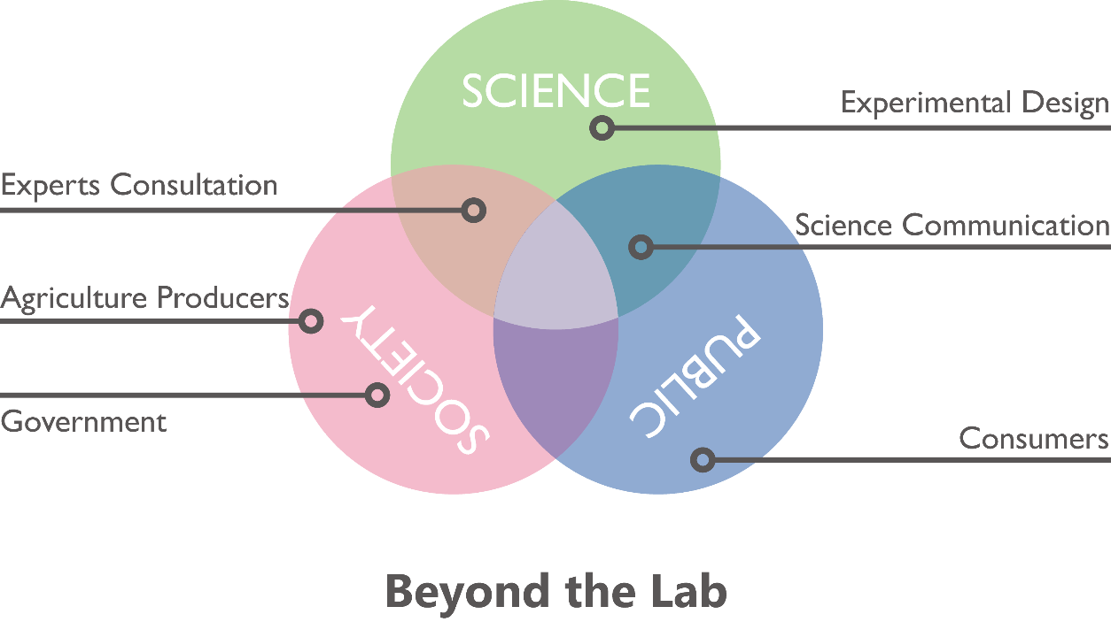

Fig. 1 Beyond the Lab

In order to better reach out and learn from diverse communities, we integrated SCIENCE, SOCIETY and PUBLIC into a new investigation method entitled “**Beyond the Lab**”(inspired by One Health) to conduct our program “Soil Lead Immobilization Magician” (SLIM). This not only guide us improve the project according to the feedback, but also help us better understand Science Communication.

The health of humans, animals and the environment are closely connected--that’s <b>“**One Health**”</b>. One Health is the integrative effort of multiple disciplines working locally, nationally, and globally to attain optimal health for people, animals, and the environment.

Besides, as the target of our help, farmers and peasants seriously suffered the lowered income as a result of the heavy metal contamination. We carry out Science Communication with the instruction of “**Push the Boundaries**”, advocating synthetic biology, healthy diet and environment safety in public, so that we can help farmers and peasants to save the loss via improving grain yield and selling heavy-metal-free vegetables with a comparatively higher price to meet the increasing demand of healthy diet.

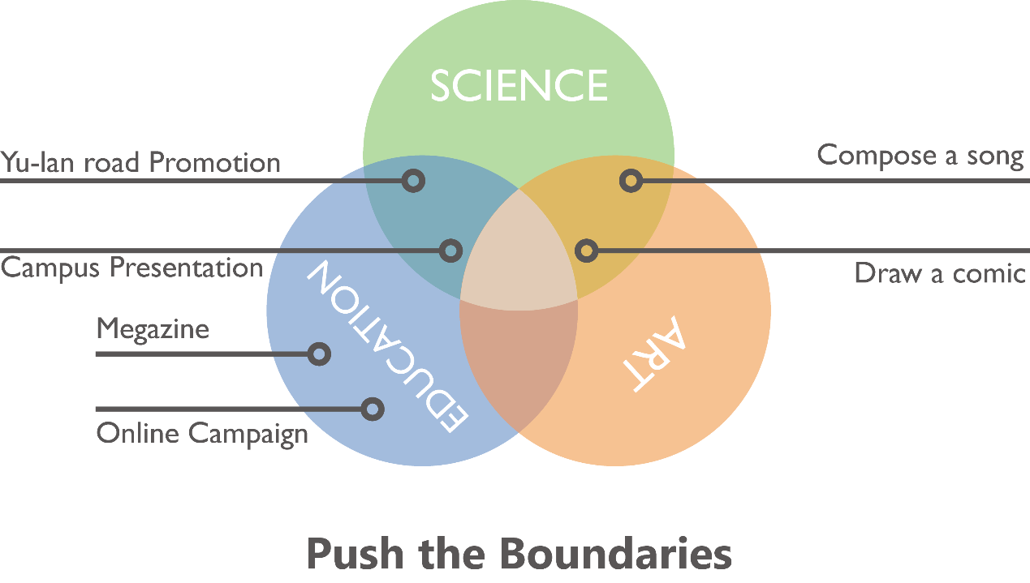

Fig. 2 Push the Boundaries

The SLIM project is like a seed. Now let’s see how SLIM help build a better future!

**1 The Birth of SLIM**

A good soil environment make the seeds germinate and grow better. A promising market make the project benefit more people and develop better. Therefore, we consulted various stakeholders, including government, agricultural enterprises and farmers to know their concerns and needs, and thus improve and shape SLIM accordingly.

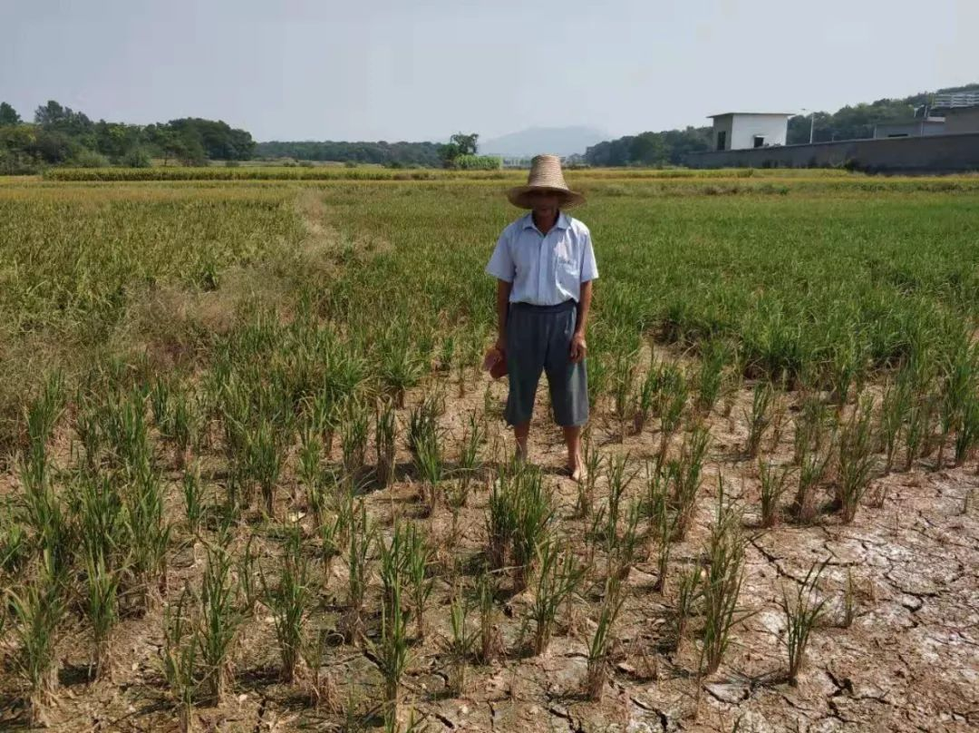

**Peasant Wang Ping**

We called Wang Ping，who said their income reduced obviously. He said that vegetables were attacked by pests, while the only solution he could come up with was the application of pesticides and fertilizers. It seemed that vegetables grew better in a short period of time. However, with high frequency of pesticide and fertilizer application,<b> **the soil was unhealthier and was inclined to agglomerate, and there were indeed fewer earthworms**, </b>resulting in a serious decline in vegetable quality and yield. He consequently suffered lower income.

Pesticides and fertilizers contain lots of heavy metals. We assume there were some relations between heavy metals, soil health, earthworms and vegetables.<b> **This little assumption inspired us to use earthworms to improve the heavy metal contaminated farmlands to increase farmland yield.** </b>We do really want to help peasants, like Wang Ping, reduce the economic loss.

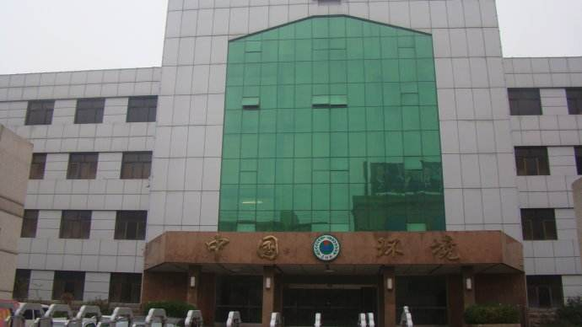

**An Official in Environmental Protection Bureau**

We interviewed an official in Environmental Protection Bureau offline. She said, “In China, there are many areas polluted by heavy metals, especially in the south. Among heavy metals, lead, cadmium, nickel have serious impacts on human body. <b>**Lead can enter human body through vegetables and grains, causing great harm to the nervous system.</b>** For example, in Chenzhou, Hunan province, where villagers suffered from lead pollution. Most villagers made a living by farming, so they were exposed to soil, crops, water and even air with leads every day. In other words, what they ate, drunk and even breathed in has been severely polluted. There were only 23,000 children in Chenzhou, but over half of them were found to have excessive levels of lead in their blood. They had symptoms like weakened immune systems, slow growth and lack of concentration. Although it’s been 10 years and the environment has been improved, **<b>the soil is still in medium pollution.</b>**”

This has drawn our great attention. <b>**We’ re determined to use the approach of synthetic biology to improve their living environment and protect their health.</b>**



**An Agricultural Enterpriser Xiao Yuan**

We interviewed Xiao Yuan, an agricultural enterpriser, via Wechat. She said, “Before planting, **soil health is the first factor to be considered.** The most common soil problem is heavy metal pollution. The sources of pollution are not only from factories, but from the chemical fertilizer and pesticides. I have known about the way of using earthworms to improve soil, but **what I’m concerned about most is the cost**. As we all know, it’s much more than just the cost of SLIM earthworms. The expenses of labour and technique and the loss of earthworms all should be considered. <b>**If your method is cheaper and more effective than others, I’ll adopt yours.**”</b>

Soil health is a primary consideration for agricultural producers, and we need to consider the **efficiency** of the project.

Due to lead pollution，grain yield has decreased，causing an economic loss to farmers. Heavy metal contaminated vegetables and crops are affecting people’s health . Humans, animals and the environment are connected. Heavy metal pollution not only poses a threat to <b>**HUMAN HEALTH</b>**, but also causes losses to <b>**ECONOMY</b>**. In order to promote harmonious development between human and nature, we utilized synthetic biology to remedy lead contaminated soil. <b>**SLIM was born</b>.**

**2 The Growth of SLIM**

To get a better understanding of the relations between humans, animals and the environment, we collaborated with One Health association. After taking the advice from One Healthers, we integrated the concept of One Health into our project to shape SLIM. What’s more, inspired by One Health, <b>**we documented two thoughtful and creative approaches to conduct our program</b>.** One is “Beyond the Lab”, the other is “Push the Boundaries”. Other iGEMers can build upon it.

**Collaboration with One Health**

**<b>One Health</b>** is a collaborative, multi-sectoral, and transdisciplinary approach—working at the local, regional, national, and global levels—with the goal of achieving **<b>optimal health</b>** outcomes recognizing the interconnection between **<b>people, animals, plants, and their shared environment</b>.**

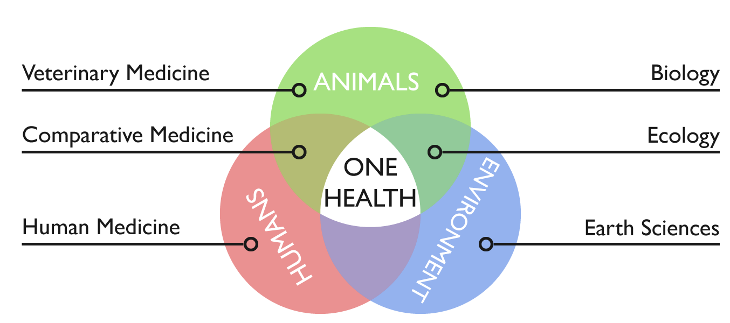

Provided by One Health Association

**<b>One Health Club NAU**</b> was founded in 2014 by a group of undergraduates who went to the University of California, Davis for a short visit. The club is now made up of students from different grades and a variety of majors including veterinary medicine, environmental science, business, etc. They focus on promoting <b>**interdisciplinary efforts</b>**, as well as popularizing One Health concept through both offline promotion and online publicity with a goal of making a difference for a better world.

**<b>How do we integrate the concept of One Health into SLIM?** On the one hand, the tolerance of earthworms is strengthened, protecting **earthworms’ safety** (animals). On the other hand, we can adress soil environmental pollution (environment), so that we can ensure agricultural development, food safety and human health.</b>

We talked with Dr. Osburn, Ms. Brunner and One Healthers in Lunch Time Challenge to share the story of SLIM. With them, we learnt how to explore the communities, institutions, or individuals affected by the problems. Most important of all is that we got kind suggestions and help from Dr. Osburn and Ms. Brunner, which helped to better shape SLIM.



**Dr. Bennie I. Osburn**

<i>Dr Osburn is Dean Emeritus, School of Veterinary Medicine, UC Davis and the director of Outreach and Training in Western Institute for Food Safety & Security. WIFSS is a University of California, Davis program of the School of Veterinary Medicine and the College of Agricultural and Environmental Sciences. In order to facilitate a better understanding of the complex interactions of humans, animals and the environment, multidisciplinary centers, institutes and programs, including WIFSS, were organized and developed during his tenure as dean.</i>

**<b>What did we know from him?</b>**

* Concept of One Health
* People’s concern about health
* Effect of soil lead contamination on human health

What we do can contribute to the protection of food safety, and we can demonstrate our works by utilizing a One Health approach.

*“Yes, <b><i>****One Health is the integrative effort of multiple disciplines working locally, nationally, and globally to attain optimal health for people, animals, and the environment.</i></b> <i>*** *I’m glad that you can utilize a One Health approach in your project. In my views, what people care about most is their health and freedom from disease. We often fail to consider the environments role with health problems affecting people, plants and animals. The topic your team has selected to study, lead toxicity, is an excellent example of an environmental problem affecting human health. Young children are often affected with lead poisoning because of contaminated, air, water or foods. Lead toxicity can affect neurological and cognitive development. There is a need for creative thinking of ways to mitigate the toxic effects of lead that is in the environment, so finding new ways of detoxifying the chemical or partitioning it out of the food or water supply is also attractive.”</i>*

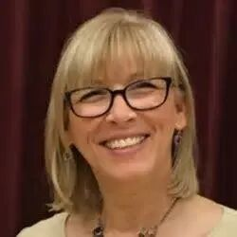

**Christie Marie Brunner**

<i>Christie Marie Brunner, as a communications and international programs director in WIFSS, devotes herself in education of One Health. She always holds an open mind to take in novel ideas and are kind enough to share relevant information.</i>

 <b>**What did we know from her?</b>**

* Health of the soil related to health of ALL living things
* Importance of teamwork and collaboration
* Information about relative researches
* Recommendation Dr. Jorge L. Mazza Rodrigues to us

We are determined to make a brochure to help people understand that we are all connected, from the soil to the table, and that goes for everything in between: plants, animals, water, air ... Besides, we spread the good word about One Health in cooperation with other iGEM teams.

*<i> “I am thrilled to know young adults such as yourself are addressing soil health and food safety through the comprehensive One Health approach. You and I know that One Health helps us by understanding that lead is naturally in the earth’s crust and once it is mined and processed it does not break down, instead it again covers the air and landscape where it is picked up by plants, animals and people.   Once it enters animals and people it causes illness and even death.  For this reason, it is important that we attempt to find ways to prevent plant, animal and human illnesses.  We care about the health of the soil as it relates to the health of ALL living things.  One Health is a difficult thing to translate to a farmer who is concerned about meeting financial obligations. When you can demonstrate that having healthy soil will allow him or her to grow more crops and make more money and provide healthy food for his or her family, and the community, the light bulb goes off and it becomes easier to make the connection between the health of the soil and the health of people.”</i>*

**Consultations with Experts**

**Consultations with Experts and other iGEMers guided our design and the experiments we conducted in the lab.** With Dr. Osburn’s advice, weconducted our work in a multi-dimensional way from the health of human, animals and environment. They helped us know how the world (Human, Animals, Environment) affects our work, and how our work affects the world.

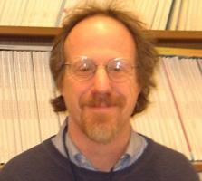

**Dr. Joseph Bressler**

**Human Health**

<i>Dr. Joseph Bressler is an expert in environmental health and blood lead from The Johns Hopkins University.</i>

**<b>We want to know…</b>**

* How blood lead affects children
* Effective treatments of blood lead

**<b>What did we know?</b>**

* Lead disease is difficult to cure, and the best treatment is to prevent.
* Chemical phosphate can insolubilize lead, thereby preventing lead diffusion.

Inspired by Dr. Joseph, <b>**we planned to use engineered bacteria to produce phosephate.</b>**

<i>*“****It’s difficult to cure and the best treatment is to prevent****. In children, the toxicokinetic of lead include absorption through the intestine via iron and calcium transporters, transfer to the blood (99% in rbc and 1% in serum), distribution to soft tissues (e.g. brain and kidney), and storage in the bone.  The bone lead remains throughout one’s life and might re-enter the blood when there is bone loss during aging. There is a strong relationship between blood and impaired cognitive development at all blood lead levels. There is no blood level thought to be safe. This is very different from other contaminants that do not increase the risk of cancer.”*

*“The rate of lead poisoning in America has declined sharply. Polluted soil is not often to see in America. However, old water pipes remain the most important problem. When water is treated with chlorine, the acidity increases leaching of the lead from the pipe, the water companies are obligated to test and adds a chemical (phosphate) to insolubilize the lead thereby preventing lead from entering the water supply. This is what happened in Flint, MI but the water company did not add phosphate.”</i>*



**Professor Guo Xianhua**

**Health of Environment**

<i>Professor Guo Xianhua is an expert in heavy metal pollution treatment from Chongqing Three Gorges University.</i>

**<b>We want to know…</b>**

* Phosphorus in soil
* The situation of lead contamination
* Existing methods of heavy metal pollution

**<b>What did we know?</b>**

* **Soluble phosphorus is very rare**
* Merits and demerits of existing methods

|  |  |  |  |
| --- | --- | --- | --- |
| Methods | Applied Range | Cost | Others |
| Plant processing | Large area | Relative low cost | **TIME-CONSUMING** |
| Soil amendments | Short-term emergency | Relative **HIGH COST** | Resorption of pollutants |
| Physical methods | **SMALL AREA** | **HIGH COST** | / |

There are **many limitations** in existing methods, so that we wanted to use synthetic biology to find a way that can ocupy these limitations.

* Lead pollution map of China

There’s much insoluble phosephorus but little soluble phosephorous, so we intended to produce **phsphate enzyme** which can transform insoluble phosephorus into soluble one, then that in turn combines with lead. According to the census shared by Professor Guo, polluted areas are often near lead-zinc deposits, like southwest and middle-of-south in China. <b>We aimed to apply it to southern China.**</b>**



**Professor Li Zhen**

**Health of Environment**

<i>Professor Li Zhen is an expert in soil edaphology from Nanjing Agricultural University.</i>

**We want to know…**

* Stability of pyromorphite and safety of forming pyromorphite in soil
* Efficiency of employing immobilization approach in soil environment
* How to verify the formation of pyromorphite in soil

**What did we know?**

* Exceptional stability of pyromorphite
* Feasibility of extending previous research to soil environment
* Employing XRD analysis to verify the formation of pyromorphite in soil

**A Question from Professor Li**

“Have you thought about the PH of phosphatase?”

After looking up data, we found that **the PH in soil is not the optimal PH of phosphatase**, then we changed phosphatase to **PHYTASE**.

*<i>“Although previous research on the formation of pyromorphite was carried out in the water system, it can be extended to the soil system. It is also safe to treat lead ions by forming pyromorphite in the soil environment, because pyromorphite is extremely stable, and effective lead cannot be extracted with TCLP (US EPA standard). In addition, many phosphate-solubilizing microorganisms in the soil are very tolerant to lead and are basically unaffected. Organic bonding state of lead in soil and other forms may affect the formation of pyromorphite, but it should not be very serious, because from the chemical balance, pyromorphite is almost the most stable lead-containing mineral. If you want to analyze and prove whether there is pyromorphite formed in the soil environment. XRD is the most effective method. Besides,* ***have you thoght about the PH of phosphatase?****”</i>*

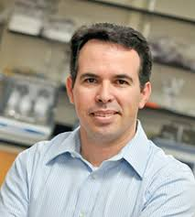

**Dr. Jorge L. Mazza Rodrigues**

**Health Of Animals**

<i>Jorge, a professor in the Department of Land, Air and Water Resources, specializes in soil microbiology. His research interests are microbial ecology, tropical forests, land use change, biodiversity, metagenomics, metaproteomic, ecological genomics, lignocellulose conversion, microbial physiology. </i>

**<b>We wanted to know…</b>**

* Dominant bacteria in soil and earthworms
* Role of microorganisms

**<b>What did we know? </b>**

* ***<b><i>Bucillus subtilis* is the dominant bacteria in soil and earthworms. <i><b>**
* Benefits of microorganisms
* **A Question from Dr. Jorge**

“Is there a possibility that engineered bacterium cause biological contamination?”

At first, we wanted to engineer Colon Bacillus. After this conversation, we planned to use **<b>*Bucillus subtilis</b>*** as engineered bacterium, and we added <b>**a kill switch to ensure the bio-safety. </b>**

*<i> “Bucillus subtilis is the dominant bacteria in soil. There are many benefits of microorganisms interacting with plants: microbes help with biocontrol of other microorganisms, promote nitrogen fixation, provide growth through hormones, allow for nutrients to be recycled and stabilize soil preventing erosion.”</i>*

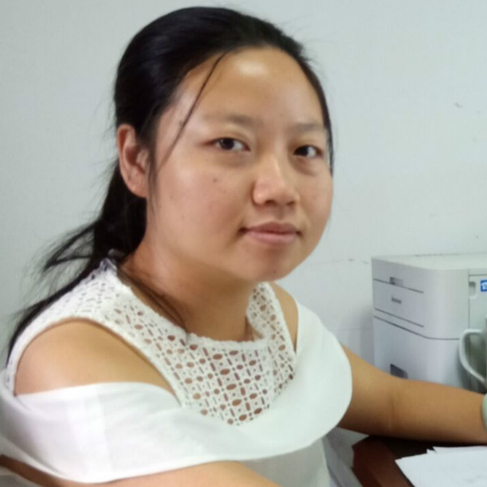

**Researcher Zhou Peixiang**

**Health of Animals**

<i>Zhou Peixiang is a researcher in management of excrements pollution of livestock and feed safety from Animal Health and Safety Center. </i>

**<b>We wanted to know…</b>**

* Effect of heavy metals on animals
* Heavy metal pollution in stock-breeding

**<b>What did we know?</b>**

* Heavy metal pollution causes a considerable economic loss to stock-breeding.
* **<b>Earthworms are tolerant to heavy metals to a certain extent.</b>**

**A Question from Ms. Zhou**

“Soil environment is complex. C**an engineered bacteria survive in the soil?”**

Engineered bacteria cannot beat against wild strains. Earthworms are tolerant to heavy metals to a certain extent. **This inspired us to find a home for bacteria, earthworms.**

*<i>“In fact, there are plants using earthworms to remove the heavy metals in excrements of livestock and poultry. The excrements contain heavy metals, and earthworms are tolerant to it. Moreover, feed is sometimes detected with heavy metals. This has a huge impact on animal productivity, causing a considerable economic loss to stock-breeding. It can also affect human health through the food chain.”</i>*

Through these conversations, <b>**we intended to engineer Bacillus subtilis to produce phytase and planted engineering bacteria into the earthworm guts.</b>** Through this combination, an automatic, pollution-free robot were born.

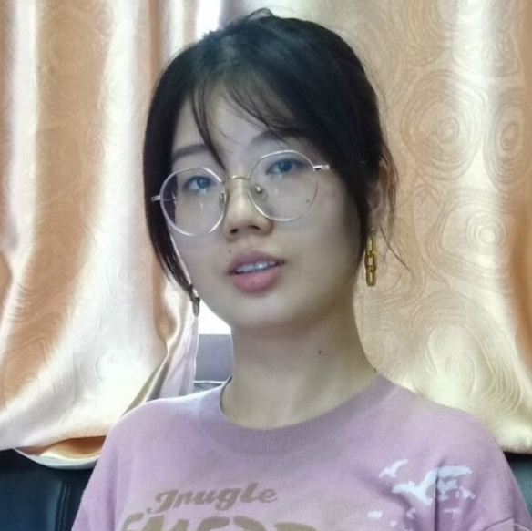

**Inspector Xu Ningyue**

**Health of Agricultural Products**

<i>Xu Ningyue is an inspector of agricultural products from The Ministry of Agriculture, China.</i>

**<b>We want to know…</b>**

* Sources of heavy metals
* Impact of heavy-metal-polllution on food safety

**<b>What did we know?</b>**

* **<b>It’s common to find problems of excessive heavy metals in agricultural products.</b>**
* Exogenous pollution and endogenous pollution
* Twelve million tons of vegetables and crops are polluted.
* A policy: Control of Soil Risk Management in Agricultural Land

*<i>****“It’s common to find problems of excessive heavy metals in agricultural products,*** *such as cadmium in paddy and lead in vegetables. The sources of heavy metals are very extensive, like industrial pollution, pesticide residues and automobile exhaust. The pollution can be divided into two parts-- exogenous pollution and endogenous pollution. The former like pesticide residues and bacteria can be easily eliminated through common wash and cooking, but the latter not. So, the only way to prevent it is to stop the gathering in vegetables. That is to solve the environmental problem. In China, 12 million tons of vegetables and crops are polluted by heavy metals every year, causing an economical loss of 20 billion yuan. The biggest losers are peasants.” Ms. Xu advised us to get more information from the policy released by the government, Control of Soil Risk Management in Agricultural Land, from which we knew heavy metals pollution is widespread in China.</i>*

1. **The Future of SLIM**

SLIM has grown up! We distributed **a questionnaire** on people’s **attitude** to SLIMand their **acceptance** of SLIM. We have noticed that most people were concerned about food safety but knew little about heavy-metal contaminated vegetables. If they could know more about these vegetables and would like to pay a bit more to buy them, farmers could benefit more. We need to greatly enhance public education. That is our **SCIENCE COMMUNICATION.**

**INFORMATION SHEET**

**QUESTIONNAIRE**

**FINDINGS**

At first, we planned to solve an emvironmentalproblem. One Health inspired us that we can do much more than that, because people, animals and environment are closely connected. We can protect food safety and human health while solving the environmental problem. Farmers, the biggest stakeholder, can earn more income. Agricultural economy can be promoted. SLIM has been influencing the world and the world has been influencing SLIM.